Web App Development Project

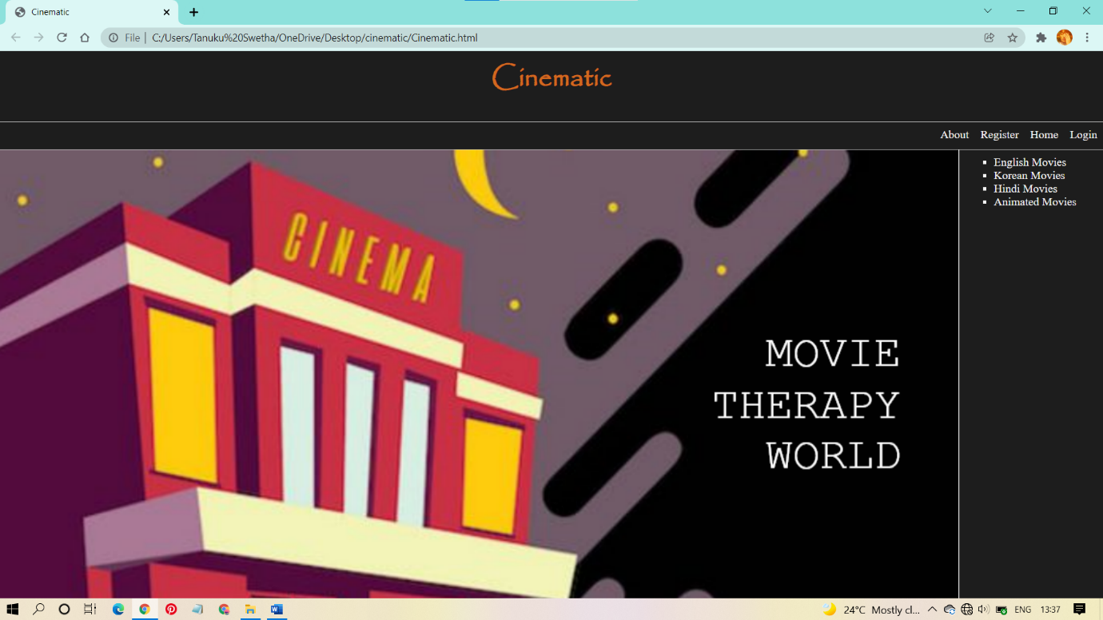

The page is divided into three rows.

1. head.html
2. tool.html
3. The third row is divided into two columns
   1. middle.html
   2. right.html

**Movies Website**

***Website name: Cinematic***

Creating the main webpage using frames

cinematic.html

<html>

<head>

<title>Cinematic</title>

</head>

<frameset rows="13%,5%,82%"border="1">

<frame name="up" src="head.html"/>

<frame name="tool" src="tool.html"/>

<frameset cols="87%,13%" border="2">

<frame name="middle" src="middle.html"/>

<frame name="right" src="right.html"/>

</frameset>

</frameset>

</html>



head



head.html

<html>

<head>

<title>Heading section</title>

</head>

<body bgcolor="#1d1d1d" background="202228 url(img/diagonal-stripes-010.png)">

<h1 style="font-family: Copperplate, Papyrus, fantasy; font-size:38px; color: chocolate; text-align: center;">

Cinematic

</h1>

</body>

</html>





tool.html

<html>

<head>

<title>login</title>

</head>

<body bgcolor="#1d1d1d" align="right">

<a href="about.html" style="text-align: left; color: #f2f2f2; text-decoration: none;" target="middle">About</a>&nbsp; &nbsp; &nbsp;

<a href="register.html" style="text-align: left; color: #f2f2f2; text-decoration: none;" target="middle">Register</a>&nbsp; &nbsp; &nbsp;

<a href="middle.html" style="text-align: left; color: #f2f2f2; text-decoration: none;" target="middle">Home</a>&nbsp; &nbsp; &nbsp;

<a href="form.html" style="text-align: right; color: #f2f2f2; text-decoration: none;" target="middle">Login</a>

</body>

</html>

&nbsp – used to give insert space

There are three links in the tool bar

1. About (about.html)
2. Register (register.html)
3. Home (middle.html)
4. Login (form.html)

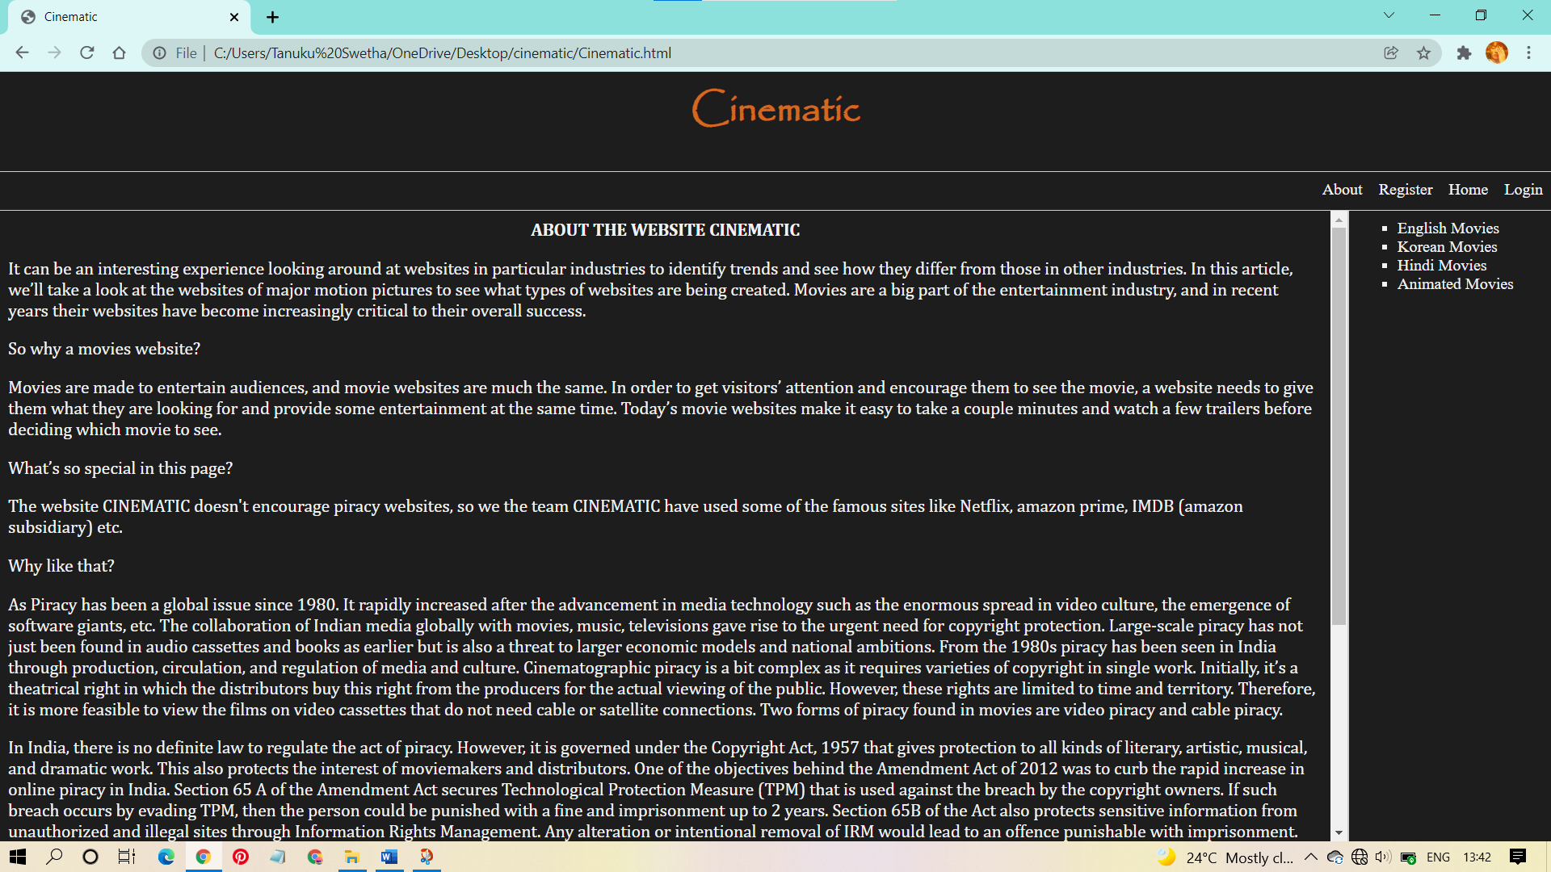

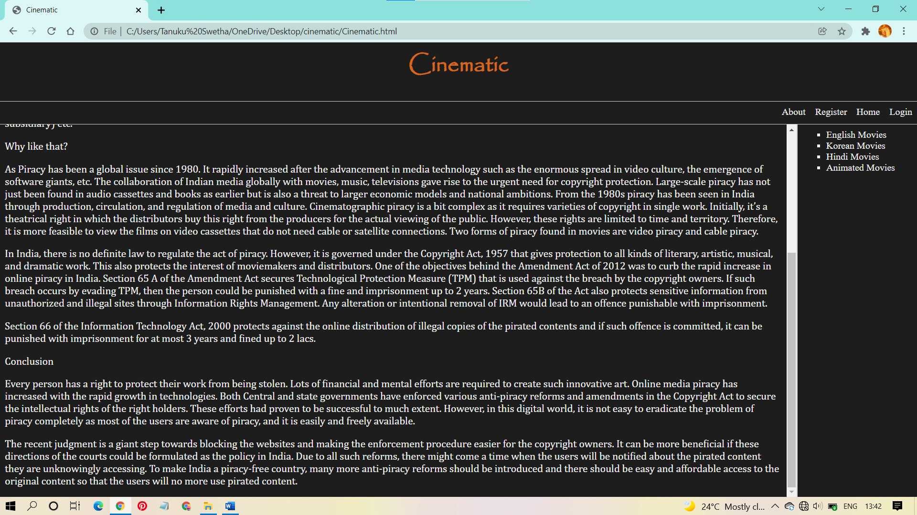

about.html

<html>

<head><title>About the website CINEMATIC</title></head>

<body bgcolor="#1d1d1d">

<h1 style="color: #f2f2f2;font-size:13pt;text-align: center; font-family: Cambria, Cochin, Georgia, Times, 'Times New Roman', serif;">ABOUT THE WEBSITE CINEMATIC</h1>

<p style="color: #f2f2f2;font-size:13pt; font-family: Cambria, Cochin, Georgia, Times, 'Times New Roman', serif;">It can be an interesting experience looking around at websites in particular industries to identify trends and see how they differ from those in other industries. In this article,

we’ll take a look at the websites of major motion pictures to see what types of websites are being created. Movies are a big part of the entertainment industry, and in recent years

their websites have become increasingly critical to their overall success.</p>

<p style="color: #f2f2f2;font-size:13pt; font-family: Cambria, Cochin, Georgia, Times, 'Times New Roman', serif;">So why a movies website?</p>

<p style="color: #f2f2f2;font-size:13pt; font-family: Cambria, Cochin, Georgia, Times, 'Times New Roman', serif;">Movies are made to entertain audiences, and movie websites are much the same. In order to get visitors’ attention and encourage them to see the movie, a website needs to give them

what they are looking for and provide some entertainment at the same time. Today’s movie websites make it easy to take a couple minutes and watch a few trailers before deciding which movie to see.</p>

<p style="color: #f2f2f2;font-size:13pt; font-family: Cambria, Cochin, Georgia, Times, 'Times New Roman', serif;">What’s so special in this page?</p>

<p style="color: #f2f2f2;font-size:13pt; font-family: Cambria, Cochin, Georgia, Times, 'Times New Roman', serif;">The website CINEMATIC doesn't encourage piracy websites, so we the team CINEMATIC have used some of the famous sites like Netflix, amazon prime, IMDB (amazon subsidiary) etc.</p>

<p style="color: #f2f2f2;font-size:13pt; font-family: Cambria, Cochin, Georgia, Times, 'Times New Roman', serif;">Why like that?</p>

<p style="color: #f2f2f2;font-size:13pt; font-family: Cambria, Cochin, Georgia, Times, 'Times New Roman', serif;">As Piracy has been a global issue since 1980. It rapidly increased after the advancement in media technology such as the enormous spread in video culture, the emergence of software

giants, etc. The collaboration of Indian media globally with movies, music, televisions gave rise to the urgent need for copyright protection. Large-scale piracy has not just been

found in audio cassettes and books as earlier but is also a threat to larger economic models and national ambitions. From the 1980s piracy has been seen in India through production,

circulation, and regulation of media and culture. Cinematographic piracy is a bit complex as it requires varieties of copyright in single work. Initially, it’s a theatrical right in

which the distributors buy this right from the producers for the actual viewing of the public. However, these rights are limited to time and territory. Therefore, it is more feasible

to view the films on video cassettes that do not need cable or satellite connections. Two forms of piracy found in movies are video piracy and cable piracy. </p>

<p style="color: #f2f2f2;font-size:13pt; font-family: Cambria, Cochin, Georgia, Times, 'Times New Roman', serif;">In India, there is no definite law to regulate the act of piracy. However, it is governed under the Copyright Act, 1957 that gives protection to all kinds of literary, artistic, musical,and dramatic work. This also protects the interest of moviemakers and distributors. One of the objectives behind the Amendment Act of 2012 was to curb the rapid increase in online piracy in India. Section 65 A of the Amendment Act secures Technological Protection Measure (TPM) that is used against the breach by the copyright owners. If such breach occurs by evading TPM, then the person could be punished with a fine and imprisonment up to 2 years. Section 65B of the Act also protects sensitive information from unauthorized and illegal sites through Information Rights Management. Any alterationor intentional removal of IRM would lead to an offence punishable with imprisonment. </p>

<p style="color: #f2f2f2;font-size:13pt; font-family: Cambria, Cochin, Georgia, Times, 'Times New Roman', serif;">Section 66 of the Information Technology Act, 2000 protects against the online distribution of illegal copies of the pirated contents and if such offence is committed, it can be punished with imprisonment for at most 3 years and fined up to 2 lacs.</p>

<p style="color: #f2f2f2;font-size:13pt; font-family: Cambria, Cochin, Georgia, Times, 'Times New Roman', serif;">Conclusion</p><p style="color: #f2f2f2;font-size:13pt; font-family: Cambria, Cochin, Georgia, Times, 'Times New Roman', serif;">Every person has a right to protect their work from being stolen. Lots of financial and mental efforts are required to create such innovative art. Online media piracy has increased with the rapid growth in technologies. Both Central and state governments have enforced various anti-piracy reforms and amendments in the Copyright Act to secure the intellectual rights of the right holders. These efforts had provento be successful to much extent. However, in this digital world, it is not easy to eradicate the problem of piracy completely as most of the users are aware of piracy, and it is easily and freely available.</p> <p style="color: #f2f2f2;font-size:13pt; font-family: Cambria, Cochin, Georgia, Times, 'Times New Roman', serif;">The recent judgment is a giant step towards blocking the websites and making the enforcement procedure easier for the copyright owners. It can be more beneficial if these directions of the courts could beformulated as the policy in India. Due to all such reforms, there might come a time when the users will be notified about the pirated content they are unknowingly accessing. To make India a piracy-free country,many more anti-piracy reforms should be introduced and there should be easy and affordable access to the original content so that the users will no more use pirated content.</p>

</pre>

</body>

</html>

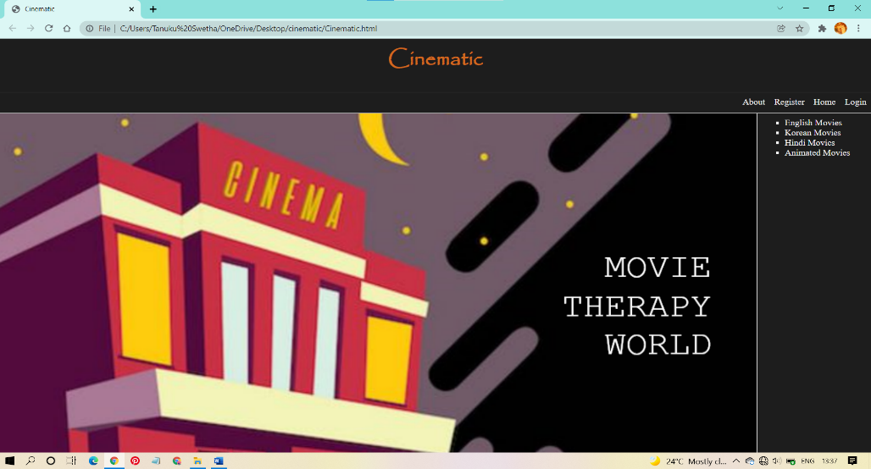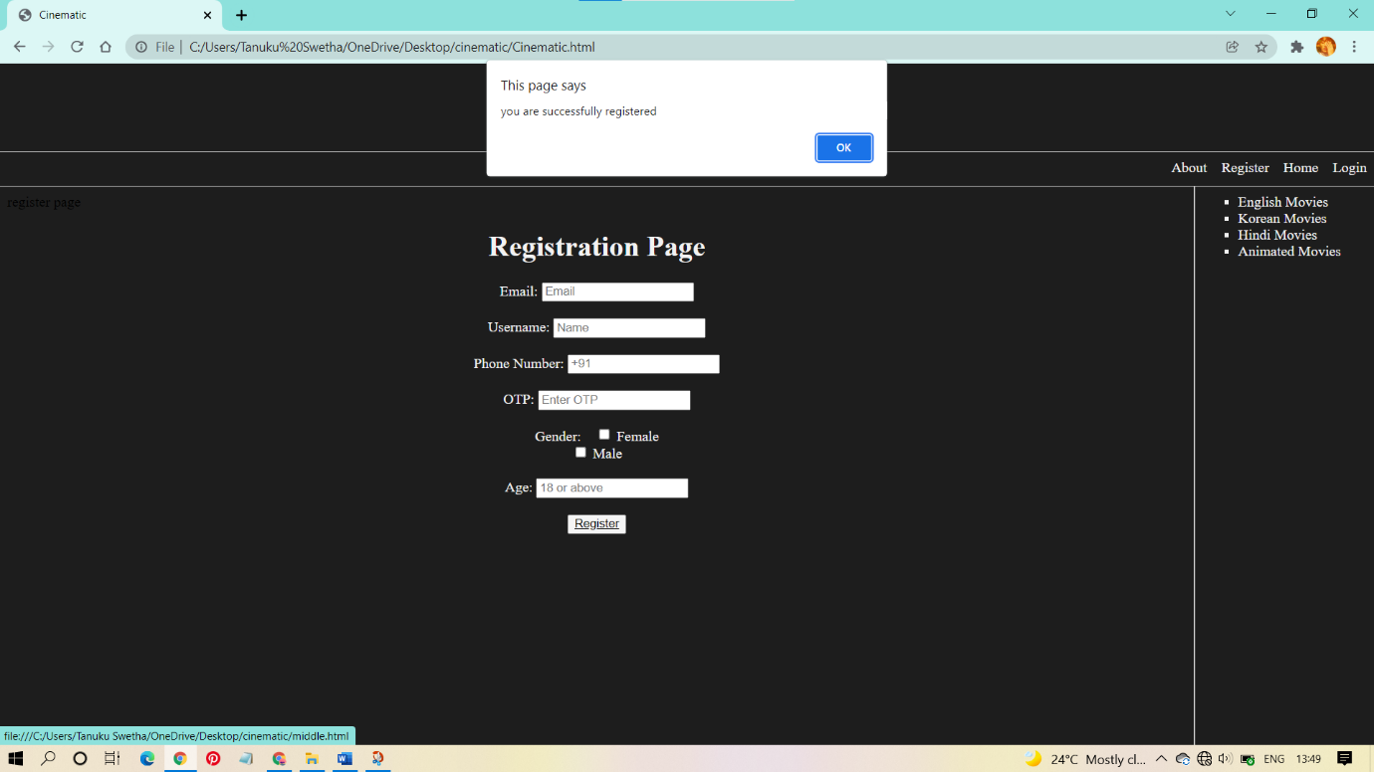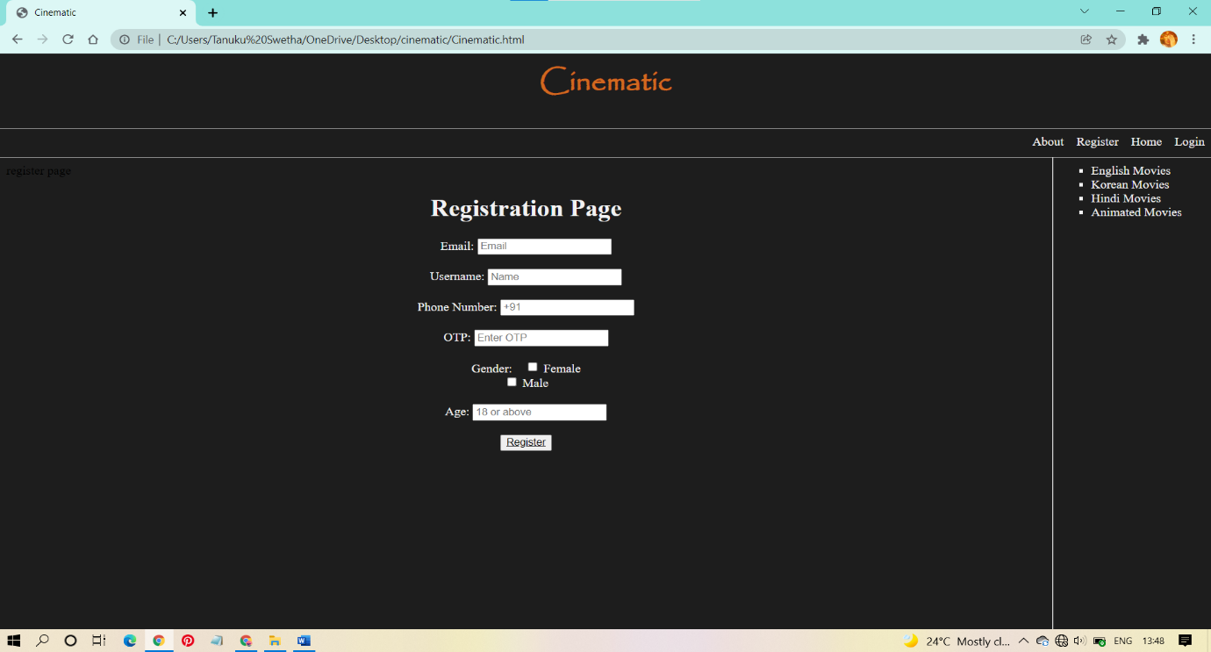This Register page gives an alert when the register button is clicked, and when the ok button is clicked in the alert pop up, then the page is redirected to home page.

1. register.html

<html>

<head>

register page

</head>

<body bgcolor="#1d1d1d">

<h1 align="center" style="color: #f2f2f2; ">Registration Page</h1>

<form align="center">

<label for="email" style="color: #f2f2f2;"> Email:</label>

<input type="text" id="email" name="email" placeholder="Email"><br><br>

<label for="name" style="color: #f2f2f2;">Username:</label>

<input type="text" id="name" name="name" placeholder="Name"><br><br>

<label for="num" style="color: #f2f2f2;">Phone Number:</label>

<input type="tel" id="num" name="num" placeholder="+91"><br><br>

<label for="otp" style="color: #f2f2f2;">OTP:</label>

<input type="password" id="otp" name="otp" placeholder="Enter OTP"><br><br>

<label for="gender" style="color: #f2f2f2;">Gender:</label>&nbsp;&nbsp;&nbsp;

<input type="checkbox" id="female" name="female" value="">

<label for="female" style="color: #f2f2f2;">Female</label><br>

<input type="checkbox" id="male" name="male" value="">

<label for="male" style="color: #f2f2f2;">Male</label><br><br>

<label for="age" style="color: #f2f2f2;">Age:</label>

<input type="tel" id="age" name="age" placeholder="18 or above"><br><br>

<button type="button" onclick="alert('you are successfully registered')" style="color: #f2f2f2;"><a href="middle.html" style="color: black;">Register</a>

</select>

</form>

</body>

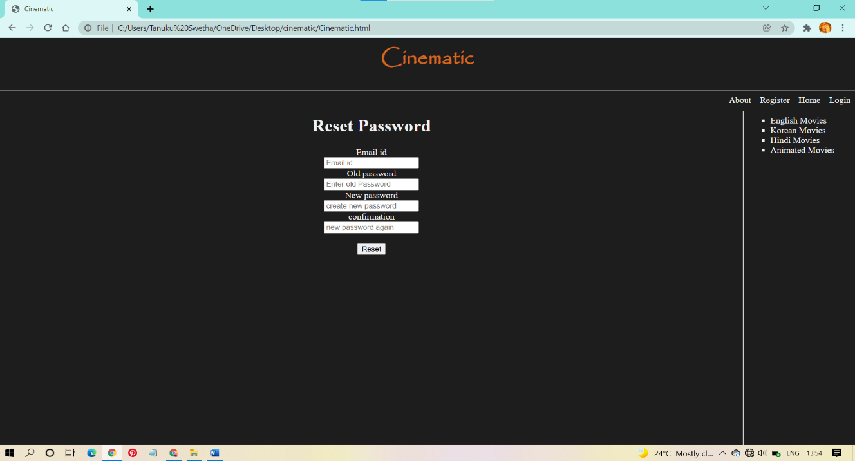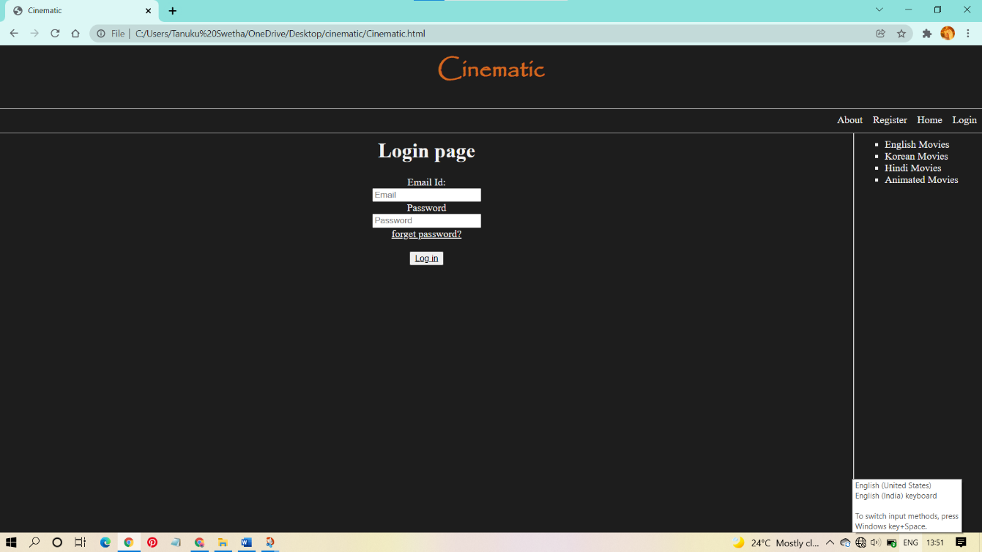<html>

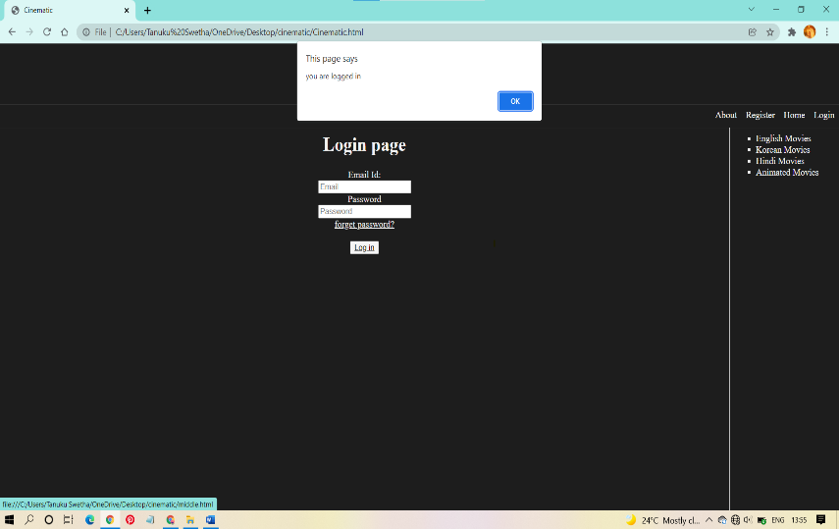when the forgot password is clicked, the reset password page is opened. In that page when reset button is clicked that page gives an alert saying ‘password reset completed’, after the ok button is clicked in the alert, again the login page is opened for the user to login with new password.

form.html

<html>

<head>

<title>

forms

</title>

</head>

<body bgcolor="#1d1d1d">

<h1 align="center" style="color: #f2f2f2;">Login page</h1>

<form align="center">

<label for="email" style="color: #f2f2f2;">Email Id:</label><br>

<input type="text" id="email" name="email" placeholder="Email"><br>

<label for="pword" style="color: #f2f2f2;">Password</label><br>

<input type="password" id="pword" name="pword" placeholder="Password"><br>

<a href="reset.html" target="middle" style="color: #f2f2f2;">forget password?</a><br><br>

<button type="button" onclick="alert('you are logged in')" style="color: ghostwhite;"><a href="" style="color: black;">Log in</a></button>

</body>

</html>

middle



middle.html

<html>

<head>

<title>Content display</title>

<style>

body

{

background-image: url("logo.png");

background-position: center;

background-size: 1500px;

background-repeat: no-repeat;

}

</style>

</head>

<body>

</body>

</html>



right



right.html

<html>

<head>

<title>List</title>

</head>

<body bgcolor="#1d1d1d">

<ul type="square">

<li style="color: #f2f2f2;"><a href="english.html" target="middle" style="color: #f2f2f2;">English Movies</a></li>

<li style="color: #f2f2f2;"><a href="korean.html" target="middle" style="color: #f2f2f2;">Korean Movies</a> </li>

<li style="color: #f2f2f2;"><a href="hindi.html" target="middle" style="color: #f2f2f2;">Hindi Movies</a></li>

<li style="color: #f2f2f2;"><a href="animated.html" target="middle" style="color: #f2f2f2;">Animated Movies</a> </li>

</ul>

</body>

</html>

The right.html contains 4 links

1. English movies (english.html)
2. Korean movies (korean.html)
3. Hindi movies (hindi.html)
4. Animated movies (animated.html)

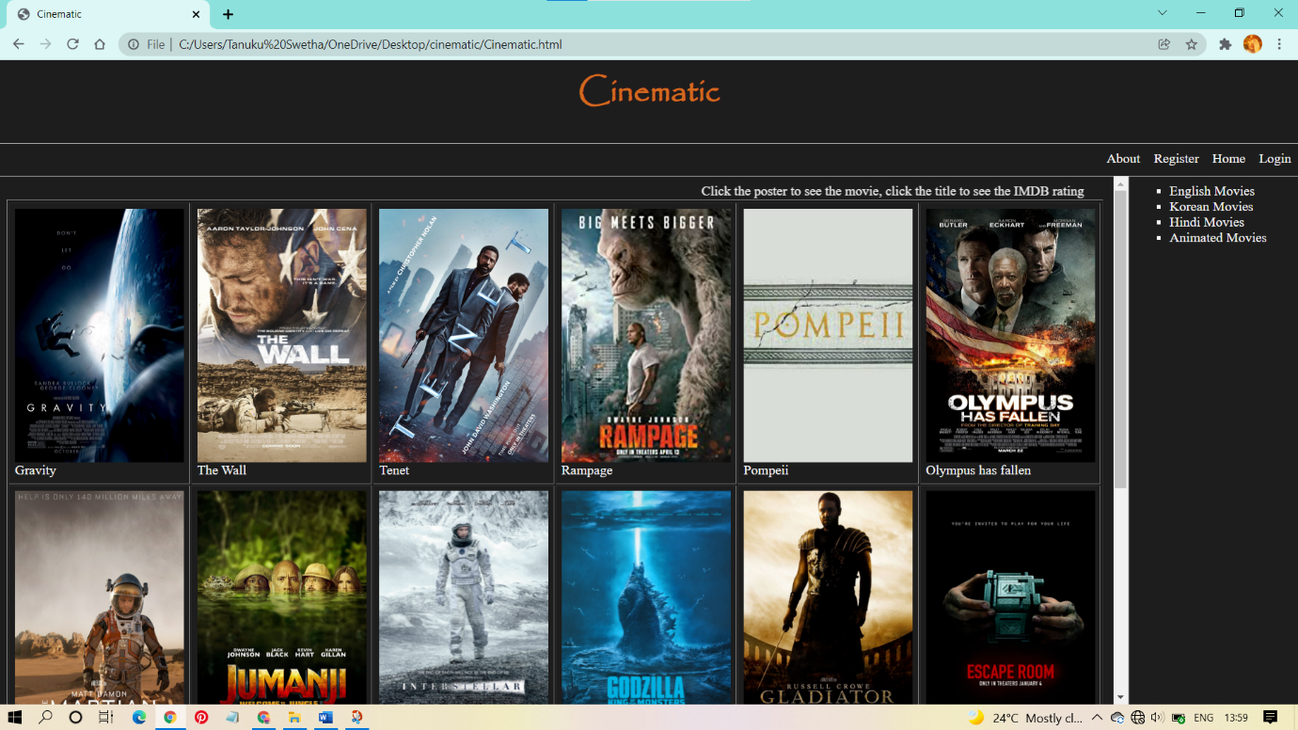

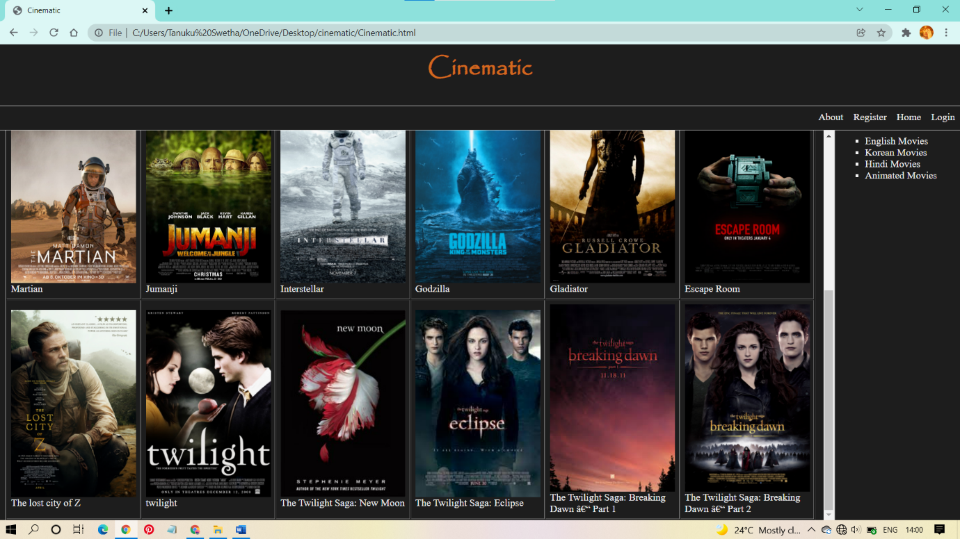

english.html

<html>

<head>

<title>English movies</title>

</head>

<body bgcolor="#1d1d1d" >

<table border="1" width=500 align="left" cellpadding=6 >

<tr><marquee width="100%" behavior="alternate" direction="right" height="19px" style=" color: #f2f2f2;">Click the poster to see the movie, click the title to see the IMDB rating</marquee></tr>

<tr><td><a href="https://www.amazon.com/Gravity-Sandra-Bullock/dp/B00HJ92QTI" target="_blank"> <img src="gravity.jpg" width="200" height="300"></a><br><a href="https://www.imdb.com/title/tt1454468/" style="color: #f2f2f2; text-decoration: none " target="_blank">Gravity</a></td>

<td><a href="https://www.amazon.com/Wall-Aaron-Taylor-Johnson/dp/B08CS3B8R2" target="_blank"><img src="wall.jpg" width="200" height="300"></a><br><a href="https://www.imdb.com/title/tt4218696/" style="color: #f2f2f2; text-decoration: none" target="_blank">The Wall</a></td>

<td><a href="https://www.primevideo.com/detail/Tenet/0LTVOZI56FO4ZEJ8GUM4LPVDDI" target="_blank"><img src="tenet.jpg" width="200"height="300"></a><br><a href="https://www.imdb.com/title/tt6723592/" style="color: #f2f2f2; text-decoration: none" target="_blank">Tenet</a></td>

<td><a href="https://www.primevideo.com/detail/Rampage/0GDRI0UZ3OD1EN85KJVC17V8B6" target="_blank"><img src="rampage.jpg" width="200" height="300" ></a><br><a href="https://www.imdb.com/title/tt2231461/" style="color: #f2f2f2; text-decoration: none" target="_blank">Rampage</a></td>

<td><a href="https://www.primevideo.com/detail/Pompeii/0OO6E4BCSJMGY7FGRD9L5Z79WC" target="_blank"><img src="pompeii.jpg" width="200" height="300" ></a><br><a href="https://www.imdb.com/title/tt1921064/?ref_=fn_al_tt_1" style="color: #f2f2f2; text-decoration: none" target="_blank">Pompeii</a></td>

<td><a href="https://www.primevideo.com/detail/Olympus-Has-Fallen/0NQ17AO8A9IQXIE0IGOAJQWOVF" target="_blank"><img src="olympus.jpg" width="200" height="300" ></a><br><a href="https://www.imdb.com/title/tt2302755/?ref_=fn_al_tt_1" style="color: #f2f2f2; text-decoration: none" target="_blank">Olympus has fallen</a></td>

</tr>

<tr><td><a href="https://www.primevideo.com/detail/The-Martian/0M6MWW4RRVCA9P6DAIVEOX2WMO" target="_blank"><img src="martian.jpg" width="200" height="300"></a><br> <a href="https://www.imdb.com/title/tt3659388/?ref_=nv_sr_srsg_0" style="color: #f2f2f2; text-decoration: none" target="_blank">Martian</a></td>

<td><a href="https://www.primevideo.com/detail/Jumanji-Welcome-to-the-Jungle/0R9X373AX96LYVD1WJDHZB487C" target="_blank"><img src="jumanji.jpg" width="200" height="300" ></a><br><a href="https://www.imdb.com/title/tt2283362/?ref_=fn_al_tt_2" style="color: #f2f2f2; text-decoration: none" target="_blank">Jumanji</a></td>

<td><a href="https://www.primevideo.com/detail/Interstellar/0I9WWNH0WX2Q545OV1W8O1SFE1" target="_blank"><img src="interstellar.jpg" width="200" height="300" ></a><br><a href="https://www.imdb.com/title/tt0816692/?ref_=nv_sr_srsg_0" style="color: #f2f2f2; text-decoration: none" target="_blank">Interstellar</a></td>

<td><a href="https://www.primevideo.com/detail/Godzilla-2014/0GDO4DO55SV2QKDXM993ZSSA3V" target="_blank"><img src="godzilla.jpg" width="200" height="300" ></a><br><a href="https://www.imdb.com/title/tt0831387/?ref_=fn_al_tt_1" style="color: #f2f2f2; text-decoration: none" target="_blank">Godzilla</a></td>

<td><a href="https://www.primevideo.com/detail/Gladiator/0QSU7OHJ4MKAPUSN8JNVRP3YQ3" target="_blank"><img src="gladitor.png" width="200" height="300" ></a><br><a href="https://www.imdb.com/title/tt0172495/?ref_=fn_al_tt_1" style="color: #f2f2f2; text-decoration: none" target="_blank">Gladiator</a></td>

<td><a href="https://www.primevideo.com/detail/Escape-Room/0JGKMSCFA73H8Q7D5KI891RTS2" target="_blank"><img src="escaperoom.png" width="200" height="300" ></a><br><a href="https://www.imdb.com/title/tt5886046/?ref_=fn_al_tt_1" style="color: #f2f2f2; text-decoration: none" target="_blank">Escape Room</a></td></tr>

<tr><td><a href="https://www.primevideo.com/detail/The-Lost-City-Of-Z/0OFJZIW73GO1N9WHT8MGS7JJ9X" target="_blank"><img src="lost.png" width="200" height="300"></a> <br><a href="https://www.imdb.com/title/tt1212428/?ref_=fn_al_tt_1" style="color: #f2f2f2; text-decoration: none" target="_blank">The lost city of Z</a></td>

<td><a href="https://www.primevideo.com/detail/Twilight/0TVM12QGIPXO4R4POSKASU6EPD" target="_blank"><img src="twilight.jpg" width="200" height="300"></a> <br><a href="https://www.imdb.com/title/tt1099212/?ref_=fn_al_tt_2" style="color: #f2f2f2; text-decoration: none" target="_blank">twilight</a></td>

<td><a href="https://www.primevideo.com/detail/The-Twilight-Saga-New-Moon/0FJU98BWPNTW0Y7UHC1NEKF3AC" target="_blank"><img src="newmoon.jpg " width="200" height="300"></a><br> <a href="https://www.imdb.com/title/tt1259571/?ref_=nv_sr_srsg_0" style="color: #f2f2f2; text-decoration: none" target="_blank">The Twilight Saga: New Moon</a></td>

<td><a href="https://www.primevideo.com/detail/The-Twilight-Saga-Eclipse/0PQGMX98FWZS5SVLBF7KFVH4A3" target="_blank"><img src="eclipse.jpg" width="200" height="300"> </a><br><a href="https://www.imdb.com/title/tt1325004/?ref_=fn_al_tt_2" style="color: #f2f2f2; text-decoration: none" target="_blank">The Twilight Saga: Eclipse</a></td>

<td><a href="https://www.primevideo.com/detail/The-Twilight-Saga-Breaking-Dawn-Part-1/0N0F7JWQLN2J4FLJ0R8CILVJ3H" target="_blank"><img src="bd.jpg" width="200" height="300"></a><br> <a href="https://www.imdb.com/title/tt1324999/?ref_=nv_sr_srsg_3" style="color: #f2f2f2; text-decoration: none" target="_blank">The Twilight Saga: Breaking Dawn – Part 1</a></td>

<td><a href="https://www.primevideo.com/detail/The-Twilight-Saga-Breaking-Dawn-Part-2/0N0CRC0PZ6A93FMK55Q4HQW1UH" target="_blank"><img src="bd2.jpg" width="200" height="300"> </a><br><a href="https://www.imdb.com/title/tt1673434/?ref_=nv_sr_srsg_0" style="color: #f2f2f2; text-decoration: none" target="_blank">The Twilight Saga: Breaking Dawn – Part 2</a></td>

</tr>

</table>

</body>

</html>

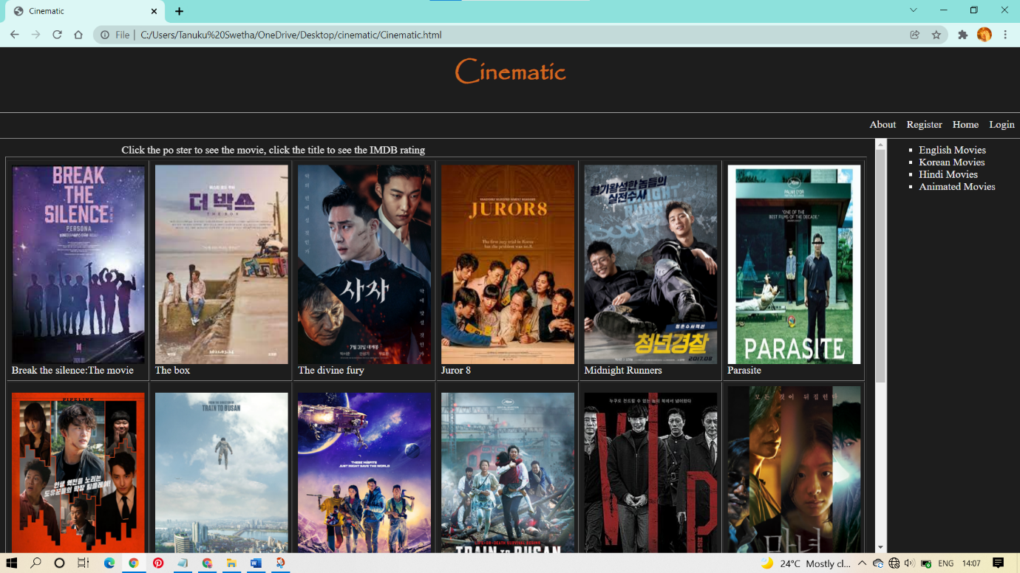

korean.html

<html>

<head>

<title>

korean movies

</title>

</head>

<body bgcolor="#1d1d1d" >

<table width=500 align="left" cellpadding=6 border="1">

<tr><tr><marquee width="100%" behavior="alternate" direction="right" height="19px" style=" color: #f2f2f2; ">Click the po ster to see the movie, click the title to see the IMDB rating</marquee></tr></tr>

<tr>

<td><img src="bts.jpg" width="200" height="300"><br><a href="https://www.imdb.com/title/tt12850582/" target="_blank" style="color: #f2f2f2; text-decoration: none;">Break the silence:The movie</a> </td>

<td><img src="box.jpg" width="200" height="300"><br><a href="https://www.imdb.com/title/tt14280066/" target="_blank" style="color: #f2f2f2; text-decoration: none;">The box</a> </td>

<td><img src="divine.jpg" width="200" height="300"><br><a href="https://www.imdb.com/title/tt10550884/" target="_blank" style="color: #f2f2f2; text-decoration: none;">The divine fury</a> </td>

<td><img src="juror.jpg" width="200" height="300"><br><a href="https://www.imdb.com/title/tt6985094/" target="_blank" style="color: #f2f2f2; text-decoration: none;">Juror 8</a> </td>

<td><img src="midnightrunners.jpg" width="200" height="300"><br><a href="https://www.imdb.com/title/tt7056732/"target="_blank" style="color: #f2f2f2; text-decoration: none;">Midnight Runners</a> </td>

<td><img src="parasite.jpg" width="200" height="300"><br><a href="https://www.imdb.com/title/tt6751668/" target="_blank" style="color: #f2f2f2; text-decoration: none;">Parasite</a> </td>

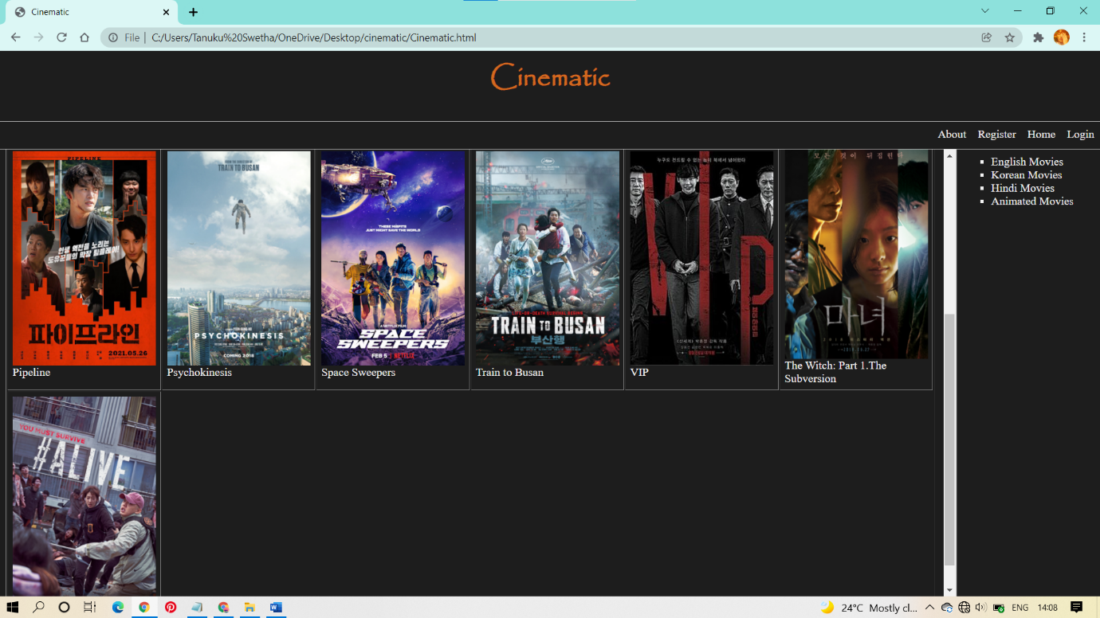

</tr>

<tr>

<td><img src="pipeline.jpg" width="200" height="300"><br><a href="https://www.imdb.com/title/tt14716932/" target="_blank" style="color: #f2f2f2; text-decoration: none;">Pipeline</a> </td>

<td><img src="psychokinesis.jpg" width="200" height="300"><br><a href="https://www.imdb.com/title/tt6890582/" target="_blank" style="color: #f2f2f2; text-decoration: none;">Psychokinesis</a> </td>

<td><img src="spacesweepers.jpg" width="200" height="300"><br><a href="https://www.imdb.com/title/tt12838766/" target="_blank" style="color: #f2f2f2; text-decoration: none;">Space Sweepers</a> </td>

<td><img src="traintobusan.jpg" width="200" height="300"><br><a href="https://www.imdb.com/title/tt5700672/" target="_blank" style="color: #f2f2f2; text-decoration: none;">Train to Busan</a> </td>

<td><img src="vip.jpg" width="200" height="300"><br><a href="https://www.imdb.com/title/tt6413410/" target="_blank" style="color: #f2f2f2; text-decoration: none;">VIP</a> </td>

<td><img src="witch.jpg"width="200" height="300"><br><a href="https://www.imdb.com/title/tt8574252/" target="_blank" style="color: #f2f2f2; text-decoration: none;">The Witch: Part 1.The Subversion </a> </td>

</tr>

<tr>

<td><img src="alive.jpg" width="200" height="300"><br><a href="https://www.imdb.com/title/tt10620868/" target="_blank" style="color: #f2f2f2; text-decoration: none;">#Alive</a></td>

</tr>

</table>

</body>

</html>

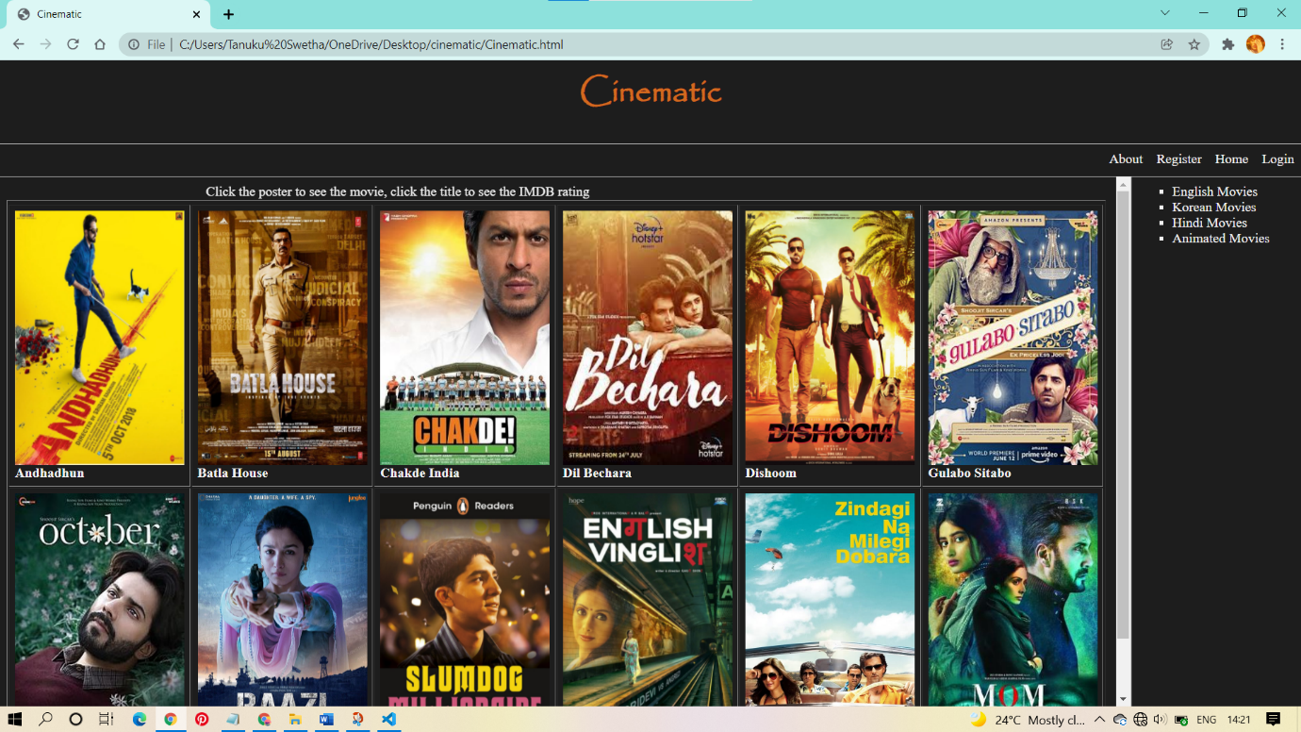

hindi.html

<html>

<head>

<title>

korean movies

</title>

</head>

<body bgcolor="#1d1d1d">

<table border="1" width=500 align="left" cellpadding=6>

<tr><tr><marquee width="100%" behavior="alternate" direction="right" height="19px" style=" color: #f2f2f2;">Click the poster to see the movie, click the title to see the IMDB rating</marquee></tr></tr>

<tr>

<td><img src="andhadhun.jpg" width="200" height="300"><br><a href="https://www.imdb.com/title/tt8108198/" target="_blank" style="color: #f2f2f2; text-decoration: none;">Andhadhun</a></td>

<td><img src="batla house.jpg" width="200" height="300"><br><a href="https://www.imdb.com/title/tt8869978/" target="_blank" style="color: #f2f2f2; text-decoration: none;">Batla House</a></td>

<td><img src="chakde.jpg" width="200" height="300"><br><a href="https://www.imdb.com/title/tt0871510/" target="_blank" style="color: #f2f2f2; text-decoration: none;">Chakde India</a></td>

<td><img src="dilbechara.jpg" width="200" height="300"><br><a href="https://www.imdb.com/title/tt8110330/" target="_blank" style="color: #f2f2f2; text-decoration: none;">Dil Bechara</a></td>

<td><img src="dishoom.jpg" width="200" height="300"><br><a href="https://www.imdb.com/title/tt3679060/" target="_blank" style="color: #f2f2f2; text-decoration: none;">Dishoom</a></td>

<td><img src="gulabo.jpg" width="200" height="300"><br><a href="https://www.imdb.com/title/tt10333912/" target="_blank" style="color: #f2f2f2; text-decoration: none;">Gulabo Sitabo</a></td>

</tr>

<tr>

<td><img src="october.jpg" width="200" height="300"><br><a href="https://www.imdb.com/title/tt7700730/" target="_blank" style="color: #f2f2f2; text-decoration: none;">October</a></td>

<td><img src="raazi.jpg" width="200" height="300"><br><a href="https://www.imdb.com/title/tt7098658/" target="_blank" style="color: #f2f2f2; text-decoration: none;">Raazi</a></td>

<td><img src="slum.jpg" width="200" height="300"><br><a href="https://www.imdb.com/title/tt1010048/" target="_blank" style="color: #f2f2f2; text-decoration: none;">Slumdog Millionaire</a></td>

<td><img src="vinglish.jpg" width="200" height="300"><br><a href="https://www.imdb.com/title/tt2181931/" target="_blank" style="color: #f2f2f2; text-decoration: none;">English Vinglish</a></td>

<td><img src="zindagi.jpg" width="200" height="300"><br><a href="https://www.imdb.com/title/tt1562872/" target="_blank" style="color: #f2f2f2; text-decoration: none;">Zindagi na milegi dobara</a></td>

<td><img src="mom.jpg" width="200" height="300"><br><a href="https://www.imdb.com/title/tt5690142/" target="_blank" style="color: #f2f2f2; text-decoration: none;">MOM</a></td>

</tr>

</table>

</body>

</html>

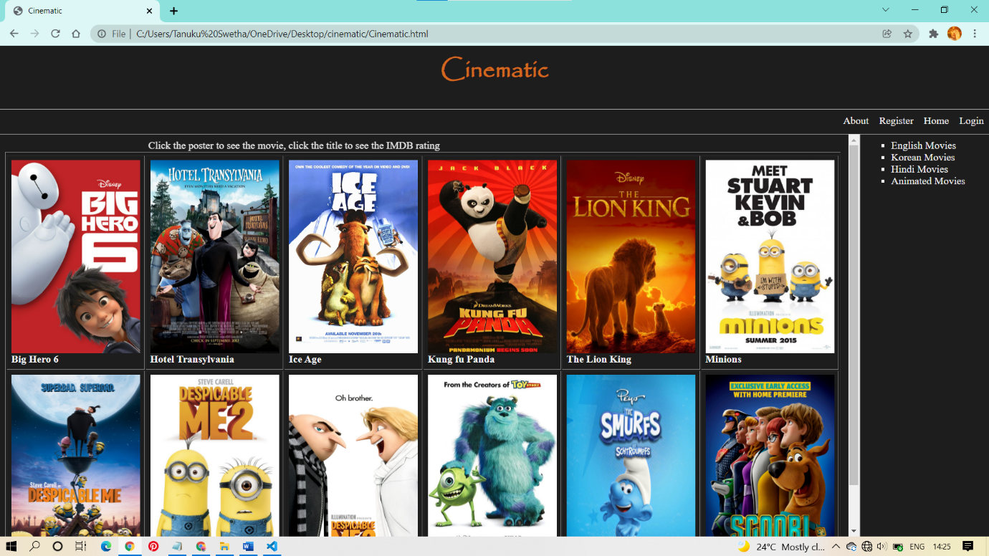

animated.html

<html>

<head>

<title>Animated Movies</title>

</head>

<body bgcolor="#1d1d1d">

<table border="1" width=500 align="left" cellpadding=6>

<tr><tr><marquee width="100%" behavior="alternate" direction="right" height="19px" style=" color: #f2f2f2;">Click the poster to see the movie, click the title to see the IMDB rating</marquee></tr></tr>

<tr>

<td><img src="hero.jpeg" width="200" height="300"><br><a href="https://www.imdb.com/title/tt2245084/" target="_blank" style="color: #f2f2f2; text-decoration: none;">Big Hero 6</a></td>

<td><img src="hotel.jpg" width="200" height="300"><br><a href="https://www.imdb.com/title/tt0837562/" target="_blank" style="color: #f2f2f2; text-decoration: none;">Hotel Transylvania</a></td>

<td><img src="iceage.jpg" width="200" height="300"><br><a href="https://www.imdb.com/title/tt0268380/" target="_blank" style="color: #f2f2f2; text-decoration: none;">Ice Age</a></td>

<td><img src="kungfu.jpg" width="200" height="300"><br><a href="https://www.imdb.com/title/tt0441773/" target="_blank" style="color: #f2f2f2; text-decoration: none;">Kung fu Panda</a></td>

<td><img src="lionking.jpg" width="200" height="300"><br><a href="https://www.imdb.com/title/tt6105098/" target="_blank" style="color: #f2f2f2; text-decoration: none;">The Lion King</a></td>

<td><img src="minions.jpg" width="200" height="300"><br><a href="https://www.imdb.com/title/tt2293640/" target="_blank" style="color: #f2f2f2; text-decoration: none;">Minions</a></td>

</tr>

<tr>

<td><img src="me.jpg" width="200" height="300"><br><a href="https://www.imdb.com/title/tt1323594/" target="_blank" style="color: #f2f2f2; text-decoration: none;">Despicable Me</a></td>

<td><img src="me2.jpg" width="200" height="300"><br><a href="https://www.imdb.com/title/tt1690953/" target="_blank" style="color: #f2f2f2; text-decoration: none;">Despicable Me 2</a></td>

<td><img src="me3.jpg" width="200" height="300"><br><a href="https://www.imdb.com/title/tt3469046/" target="_blank" style="color: #f2f2f2; text-decoration: none;">Despicable Me 3</a></td>

<td><img src="monster.jpg" width="200" height="300"><br><a href="https://www.imdb.com/title/tt0198781/" target="_blank" style="color: #f2f2f2; text-decoration: none;">Monster ,INC.</a></td>

<td><img src="smurf.jpg" width="200" height="300"><br><a href="https://www.imdb.com/title/tt0472181/" target="_blank" style="color: #f2f2f2; text-decoration: none;">The Smurfs</a></td>

<td><img src="scoob.png" width="200" height="300"><br><a href="https://www.imdb.com/title/tt3152592/" target="_blank" style="color: #f2f2f2; text-decoration: none;">Scoob</a></td>

</tr>

</table>

</body>

</html>